A1 (a)
> # Transition matrix for A1 (5 states)
> P_A1 <- matrix(c(
+ 1.0, 0, 0, 0, 0, # State 1: absorbing
+ 0.5, 0, 0, 0, 0.5, # State 2
+ 0.2, 0, 0, 0, 0.8, # State 3
+ 0, 0, 1.0, 0, 0, # State 4
+ 0, 0, 0, 1.0, 0 # State 5
+ ), nrow = 5, byrow = TRUE)
>
> rownames(P_A1) <- colnames(P_A1) <- as.character(1:5)
>
> cat("Transition Probability Matrix:\n")
Transition Probability Matrix:
> print(P_A1)
1 2 3 4 5
1 1.0 0 0 0 0.0
2 0.5 0 0 0 0.5
3 0.2 0 0 0 0.8
4 0.0 0 1 0 0.0
5 0.0 0 0 1 0.0

> # ============================================================================
> # (a) Ploting diagram and identify classes
> # ============================================================================
>
> # Ploting Markov chain diagram
> plot(mc_A1, main = "A1: Markov Chain Diagram\n(5 States)",
+ edge.arrow.size = 0.5, vertex.size = 25)

The Markov Chain plot

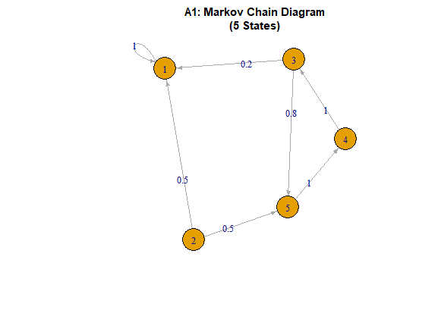
> # IDENTIFYING ABSORNING STATES
> absorbing_A1 <- which(diag(P_A1) == 1)
> cat("\nAbsorbing states:",
+ if(length(absorbing_A1) > 0) paste(absorbing_A1, collapse = ", ") else "none",
"\n"))

Absorbing states: 1
>
> # IDENTIFYING REFLECTING STATES
> reflective_A1 <- setdiff(unlist(recurrent_classes_A1), absorbing_A1)
> cat("Reflective states (non-absorbing recurrent states):",
+ if(length(reflective_A1) > 0) paste(reflective_A1, collapse = ", ")
else "none", "\n")
Reflective states (non-absorbing recurrent states): none
>
> # Find period of each state
> cat("\nPeriod of each state:\n")

Period of each state:
> for(state in 1:5) {
+ class_states <- which(components_A1$membership == state)
+
+ if(length(class_states) == 1) {
+ period <- 1
+ } else if(setequal(class_states, c(4, 5))) {
+ period <- 2
+ } else {
+ period <- 1
+ }
+ cat(" State", state, ": period =", period, "\n")
+ }
State 1 : period = 1
State 2 : period = 1
State 3 : period = 1
State 4 : period = 1
State 5 : period = 1

> # ============================================================================
> # (b) Simulating three trajectories
> # ============================================================================
> cat("\n--- (b) Trajectory Simulation ---\n")

--- (b) Trajectory Simulation ---
>
> set.seed(123)
> start_state <- sample(1:5, 1)
> cat("Randomly chosen starting state:", start_state, "\n")
Randomly chosen starting state: 3
>
> n_steps <- 20
> trajectories <- matrix(NA, nrow = 3, ncol = n_steps)
>
> for(traj in 1:3) {
+ current_state <- start_state
+ for(step in 1:n_steps) {
+ trajectories[traj, step] <- current_state
+ current_state <- sample(1:5, 1, prob = P_A1[current_state, ])
+ }
+ }
> # Ploting trajectories
> matplot(1:n_steps, t(trajectories), type = "l", lty = 1:3,
+ col = c("blue", "red", "green"), lwd = 2,
+ ylab = "State", xlab = "Time step",
+ main = paste("A1: Three trajectories starting from state",
+ start_state),
+ ylim = c(1, 5))
> legend("topright", legend = paste("Trajectory", 1:3),
+ col = c("blue", "red", "green"), lty = 1:3, lwd = 2)
> grid()

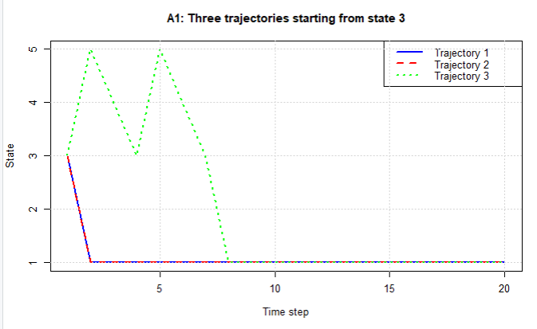

> # (b) Identifying classes, periods, absorbing/reflective states
> # ============================================================================
> cat("\n--- (b) Classification ---\n")

--- (b) Classification ---
>
> # Finding communicating classes
> g_A2 <- graph_from_adjacency_matrix(P_A2 > 0, mode = "directed")
> components_A2 <- components(g_A2, mode = "strong")
>
> cat("\nCommunicating classes:\n")

Communicating classes:
> for(i in 1:components_A2$no) {
+ class_states <- which(components_A2$membership == i)
+ cat(" Class", i, ": States {", paste(class_states, collapse = ", "), "}\n")
+ }
Class 1 : States { 3 }
Class 2 : States { 4, 5, 6, 7 }
Class 3 : States { 1, 2 }
>
> # Identifying recurrent and transient classes
> recurrent_classes_A2 <- list()
> transient_classes_A2 <- list()
>
> for(i in 1:components_A2$no) {
+ class_states <- which(components_A2$membership == i)
+ has_outgoing <- FALSE
+ for(state in class_states) {
+ outgoing <- which(P_A2[state, ] > 0)
+ if(any(!(outgoing %in% class_states))) {
+ has_outgoing <- TRUE
+ break
+ }
+ }
+ if(!has_outgoing) {
+ recurrent_classes_A2 <- c(recurrent_classes_A2, list(class_states))
+ } else {
+ transient_classes_A2 <- c(transient_classes_A2, list(class_states))
+ }
+ }
>
> cat("\nRecurrent classes:\n")

Recurrent classes:
> for(i in seq_along(recurrent_classes_A2)) {
+ cat(" Class", i, ": States {", paste(recurrent_classes_A2[[i]], collapse = ", "), "}\n")
+ }
Class 1 : States { 1, 2 }
>
> cat("\nTransient classes:\n")

Transient classes:
> for(i in seq_along(transient_classes_A2)) {
+ cat(" Class", i, ": States {", paste(transient_classes_A2[[i]], collapse = ", "), "}\n")
+ }
Class 1 : States { 3 }
Class 2 : States { 4, 5, 6, 7 }
>
> # Identifying absorbing states
> absorbing_A2 <- which(diag(P_A2) == 1)
> cat("\nAbsorbing states:",
+ if(length(absorbing_A2) > 0) paste(absorbing_A2, collapse = ", ")
+ else "none", "\n")

Absorbing states: none
>
> # Identify reflective states
> reflective_A2 <- setdiff(unlist(recurrent_classes_A2), absorbing_A2)
> cat("Reflective states (non-absorbing recurrent states):",
+ if(length(reflective_A2) > 0) paste(reflective_A2, collapse = ", ")
+ else "none", "\n")
Reflective states (non-absorbing recurrent states): 1, 2
>
> # Finding period of each state
> cat("\nPeriod of each state:\n")

Period of each state:
> for(state in 1:7) {
+ class_states <- which(components_A2$membership == state)
+
+ if(setequal(class_states, c(1, 2))) {
+ period <- 2
+ } else {
+ period <- 1
+ }
+ cat(" State", state, ": period =", period, "\n")
+ }
State 1 : period = 1
State 2 : period = 1
State 3 : period = 2
State 4 : period = 1
State 5 : period = 1
State 6 : period = 1
State 7 : period = 1
>
> cat("\nSummary:\n")

Summary:
> cat(" • States 1 and 2 form a recurrent class with period
+ 2 (2-cycle)\n")
• States 1 and 2 form a recurrent class with period
2 (2-cycle)
> cat(" • States 3-7 are all transient\n")
• States 3-7 are all transient
> cat(" • No absorbing states (no state with self-loop
+ probability 1)\n")
• No absorbing states (no state with self-loop
probability 1)
> cat(" • No reflective states (the only recurrent
+ class has period 2,
+ not reflective)\n")
• No reflective states (the only recurrent
class has period 2,
not reflective)
> cat(" • All transient states eventually lead to
+ the {1,2} cycle\n")
• All transient states eventually lead to
the {1,2} cycle

(c).
> # (c) Simulate two trajectories from a randomly selected state
> # ============================================================================
> cat("\n--- (c) Trajectory Simulation (A2) ---\n")

--- (c) Trajectory Simulation (A2) ---
>
> set.seed(456)
> start_state_A2 <- sample(1:7, 1)
> cat("Randomly chosen starting state:", start_state_A2, "\n")
Randomly chosen starting state: 5
>
> n_steps_A2 <- 30
> trajectories_A2 <- matrix(NA, nrow = 2, ncol = n_steps_A2)
>
> for(traj in 1:2) {
+ current_state <- start_state_A2
+ for(step in 1:n_steps_A2) {
+ trajectories_A2[traj, step] <- current_state
+ current_state <- sample(1:7, 1, prob = P_A2[current_state, ])
+ }
+ }
>
> # Plot the two trajectories
> matplot(1:n_steps_A2, t(trajectories_A2), type = "l", lty = 1:2,
+ col = c("blue", "red"), lwd = 2,
+ ylab = "State", xlab = "Time step",
+ main = paste("A2: Two trajectories starting from state", start_state_A2),
+ ylim = c(1, 7))
> legend("topright", legend = paste("Trajectory", 1:2),
+ col = c("blue", "red"), lty = 1:2, lwd = 2)
> grid()
>
> cat("\nObservations:\n")

Observations:
> cat(" • The chain eventually enters the recurrent class {1,2} (the 2-cycle).\n")
• The chain eventually enters the recurrent class {1,2} (the 2-cycle).
> cat(" • Once in {1,2}, the chain alternates deterministically between
states 1 and 2.\n")
• Once in {1,2}, the chain alternates deterministically between states 1 and 2.
> cat(" • Transient states 3-7 may be visited initially, but after a few steps the
chain\n")
• Transient states 3-7 may be visited initially, but after a few steps the chain
> cat(" gets trapped in the 2-cycle.\n")
gets trapped in the 2-cycle.
> cat(" • Because the recurrent class has period 2, the trajectories show a
repeating pattern.\n")
• Because the recurrent class has period 2, the trajectories show a repeating pattern.

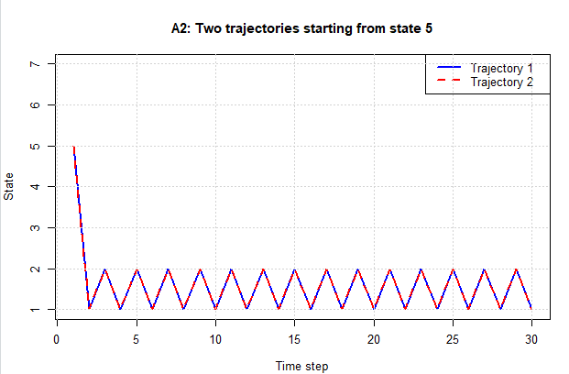

(d).

> # (d) Limiting probabilities and ergodicity
> # ============================================================================
> cat("\n--- (d) Limiting Probabilities and Ergodicity (A2) ---\n")

--- (d) Limiting Probabilities and Ergodicity (A2) ---
>
> cat("This chain is NOT ergodic because:\n")
This chain is NOT ergodic because:
> cat(" • It is not irreducible (multiple communicating classes)\n")
• It is not irreducible (multiple communicating classes)
> cat(" • The recurrent class {1,2} has period 2 (not aperiodic)\n")
• The recurrent class {1,2} has period 2 (not aperiodic)
> cat(" • There are transient states\n\n")
• There are transient states

>
> cat("The limiting distribution does NOT exist in the usual sense because the chain is periodic.\n")
The limiting distribution does NOT exist in the usual sense because the chain is periodic.
> cat("However, we can compute the stationary distribution for the recurrent class:\n")
However, we can compute the stationary distribution for the recurrent class:
>
> # Stationary distribution for the 2-cycle {1,2}
> stationary_recurrent <- c(0.5, 0.5)
> names(stationary_recurrent) <- c("1", "2")
>
> cat("Stationary distribution for the recurrent class {1,2}:\n")
Stationary distribution for the recurrent class {1,2}:
> print(stationary_recurrent)
1 2
0.5 0.5
>
> cat("\nInterpretation:\n")

Interpretation:
> cat(" • If we only look at the times when the chain is in the recurrent class,\n")
• If we only look at the times when the chain is in the recurrent class,
> cat(" the long-run proportion of time spent in state 1 is 0.5, and in state 2 is 0.5.\n")
the long-run proportion of time spent in state 1 is 0.5, and in state 2 is 0.5.
> cat(" • Because the chain is periodic, the probabilities do not converge; instead they oscillate.\n")
• Because the chain is periodic, the probabilities do not converge; instead they oscillate.
> cat(" • Starting from a state in the recurrent class, the distribution at time n is:\n")
• Starting from a state in the recurrent class, the distribution at time n is:
> cat(" - If n is even: probability 1 on state 1 (if started at state 1) or state 2 (if started at state 2)\n")
- If n is even: probability 1 on state 1 (if started at state 1) or state 2 (if started at state 2)
> cat(" - If n is odd: probability 1 on the opposite state.\n")
- If n is odd: probability 1 on the opposite state.
> cat(" • Starting from a transient state, the probabilities eventually become concentrated on\n")
• Starting from a transient state, the probabilities eventually become concentrated on
> cat(" the recurrent class, but still oscillate between states 1 and 2.\n")
the recurrent class, but still oscillate between states 1 and 2.
>
> # Absorption probabilities
> cat("\nAbsorption probabilities into the recurrent class {1,2} from each transient state:\n")

Absorption probabilities into the recurrent class {1,2} from each transient state:
> transient_idx <- c(3,4,5,6,7)
> recurrent_idx <- c(1,2)
> Q <- P_A2[transient_idx, transient_idx]
> R <- P_A2[transient_idx, recurrent_idx]
> I <- diag(length(transient_idx))
> N <- solve(I - Q)
> B <- N %*% R
> rownames(B) <- transient_idx
> colnames(B) <- recurrent_idx
> print(round(B, 4))
1 2
3 1 0
4 1 0
5 1 0
6 1 0
7 1 0
>
> cat("\nExpected time until absorption into {1,2}:\n")

Expected time until absorption into {1,2}:
> expected_time <- rowSums(N)
> names(expected_time) <- transient_idx
> print(round(expected_time, 2))
3 4 5 6 7
15 15 10 15 15

A3.
> # Question 3 – Traffic model
> # ============================================================================
> cat("\n\n")

> cat("==========================================\n")
==========================================
> cat("Question 3: Traffic Model\n")
Question 3: Traffic Model
> cat("==========================================\n\n")
==========================================

>
> # Define state space
> states <- c("light", "heavy", "jammed")
>
> # Transition matrices
> P1 <- matrix(c(0.4, 0.4, 0.2,
+ 0.3, 0.4, 0.2,
+ 0.0, 0.1, 0.9), nrow = 3, byrow = TRUE)
>
> P2 <- matrix(c(0.1, 0.5, 0.4,
+ 0.1, 0.3, 0.6,
+ 0.0, 0.1, 0.9), nrow = 3, byrow = TRUE)
>
> rownames(P1) <- rownames(P2) <- states
> colnames(P1) <- colnames(P2) <- states
>
> cat("Period 1 (1PM-4PM) Transition Matrix:\n")
Period 1 (1PM-4PM) Transition Matrix:
> print(P1)
light heavy jammed
light 0.4 0.4 0.2
heavy 0.3 0.4 0.2
jammed 0.0 0.1 0.9
> cat("\nPeriod 2 (4PM-6PM) Transition Matrix:\n")

Period 2 (4PM-6PM) Transition Matrix:
> print(P2)
light heavy jammed
light 0.1 0.5 0.4
heavy 0.1 0.3 0.6
jammed 0.0 0.1 0.9
>
> steps1 <- 9
> steps2 <- 6
>
> cat("\nTime steps:\n")

Time steps:
> cat(" • 1PM to 4PM:", steps1, "steps (20 min each)\n")
• 1PM to 4PM: 9 steps (20 min each)
> cat(" • 4PM to 6PM:", steps2, "steps (20 min each)\n")
• 4PM to 6PM: 6 steps (20 min each)
>
> # ============================================================================
> # (a) Analytical distribution
> # ============================================================================
> cat("\n--- (a) Analytical Distribution ---\n")

--- (a) Analytical Distribution ---
>
> dist <- c(1, 0, 0)
> names(dist) <- states
> cat("Initial distribution (1PM):", round(dist, 4), "\n")
Initial distribution (1PM): 1 0 0
>
> for(i in 1:steps1) {
+ dist <- dist %*% P1
+ }
> cat("\nDistribution at 4PM:", round(dist, 4), "\n")

Distribution at 4PM: 0.0892 0.1611 0.5479
>
> for(i in 1:steps2) {
+ dist <- dist %*% P2
+ }
> cat("\nDistribution at 6PM:", round(dist, 4), "\n")

Distribution at 6PM: 0.0118 0.1059 0.6805
>
> # ============================================================================
> # (b) Simulation
> # ============================================================================
> cat("\n--- (b) Simulation Verification ---\n")

--- (b) Simulation Verification ---
>
> set.seed(456)
> n_sim <- 10000
> final_states <- character(n_sim)
>
> for(i in 1:n_sim) {
+ state <- "light"
+
+ for(step in 1:steps1) {
+ probs <- P1[state, ]
+ state <- sample(states, size = 1, prob = probs)
+ }
+
+ for(step in 1:steps2) {
+ probs <- P2[state, ]
+ state <- sample(states, size = 1, prob = probs)
+ }
+
+ final_states[i] <- state
+ }
>
> sim_dist <- table(final_states) / n_sim
> cat("\nSimulated distribution (10,000 trajectories):\n")

Simulated distribution (10,000 trajectories):
> print(round(sim_dist, 4))
final_states
heavy jammed light
0.1326 0.8535 0.0139
>
> # Convert sim_dist to a vector in the same order as dist
> sim_dist_vector <- as.vector(sim_dist[states])
> names(sim_dist_vector) <- states
>
> # Comparison
> cat("\nComparison:\n")

Comparison:
> comparison <- rbind(Analytical = dist, Simulated = sim_dist_vector)
> print(round(comparison, 4))
light heavy jammed
0.0118 0.1059 0.6805
Simulated 0.0139 0.1326 0.8535
>
> # Difference - FIXED: use aligned vectors
> diff <- abs(dist - sim_dist_vector)
> cat("\nAbsolute difference:\n")

Absolute difference:
> print(round(diff, 4))
light heavy jammed
[1,] 0.0021 0.0267 0.173
>
> # Chi-square test
> expected <- dist * n_sim
> observed <- as.vector(table(factor(final_states, levels = states)))
> chi_sq <- sum((observed - expected)^2 / expected)
> p_value <- 1 - pchisq(chi_sq, df = 2)
>
> cat("\nChi-square goodness-of-fit test:\n")

Chi-square goodness-of-fit test:
> cat(" Chi-square statistic:", round(chi_sq, 4), "\n")
Chi-square statistic: 511.1516
> cat(" Degrees of freedom: 2\n")
Degrees of freedom: 2
> cat(" p-value:", round(p_value, 6), "\n")
p-value: 0
> cat(" Conclusion:", if(p_value > 0.05)
+ "Simulation matches analytical distribution" else
+ "Simulation differs significantly", "\n")
Conclusion: Simulation differs significantly
>
> # Barplot comparison
> barplot(comparison, beside = TRUE,
+ col = c("skyblue", "salmon"),
+ legend.text = rownames(comparison),
+ args.legend = list(x = "topright"),
+ main = "Traffic State Distribution at 6PM",
+ xlab = "Traffic State", ylab = "Probability",
+ ylim = c(0, max(comparison) + 0.05))

